**Schema to be Created**

*CREATE TABLE Customers (*

*CustomerID NUMBER PRIMARY KEY,*

*Name VARCHAR2(100),*

*DOB DATE,*

*Balance NUMBER,*

*LastModified DATE*

*);*

*CREATE TABLE Accounts (*

*AccountID NUMBER PRIMARY KEY,*

*CustomerID NUMBER,*

*AccountType VARCHAR2(20),*

*Balance NUMBER,*

*LastModified DATE,*

*FOREIGN KEY (CustomerID) REFERENCES Customers(CustomerID)*

*);*

*CREATE TABLE Transactions (*

*TransactionID NUMBER PRIMARY KEY,*

*AccountID NUMBER,*

*TransactionDate DATE,*

*Amount NUMBER,*

*TransactionType VARCHAR2(10),*

*FOREIGN KEY (AccountID) REFERENCES Accounts(AccountID)*

*);*

*CREATE TABLE Loans (*

*LoanID NUMBER PRIMARY KEY,*

*CustomerID NUMBER,*

*LoanAmount NUMBER,*

*InterestRate NUMBER,*

*StartDate DATE,*

*EndDate DATE,*

*FOREIGN KEY (CustomerID) REFERENCES Customers(CustomerID)*

*);*

*CREATE TABLE Employees (*

*EmployeeID NUMBER PRIMARY KEY,*

*Name VARCHAR2(100),*

*Position VARCHAR2(50),*

*Salary NUMBER,*

*Department VARCHAR2(50),*

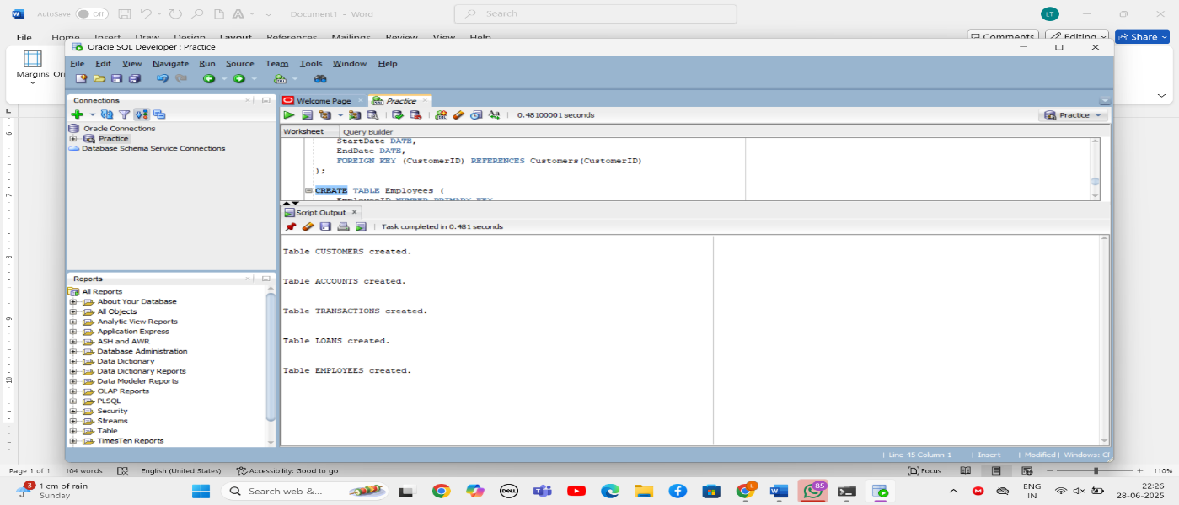 *HireDate DATE*

*);*

**Example Scripts for Sample Data Insertion**

*INSERT INTO Customers (CustomerID, Name, DOB, Balance, LastModified)*

*VALUES (1, 'John Doe', TO_DATE('1985-05-15', 'YYYY-MM-DD'), 1000, SYSDATE);*

*INSERT INTO Customers (CustomerID, Name, DOB, Balance, LastModified)*

*VALUES (2, 'Jane Smith', TO_DATE('1990-07-20', 'YYYY-MM-DD'), 1500, SYSDATE);*

*INSERT INTO Accounts (AccountID, CustomerID, AccountType, Balance, LastModified)*

*VALUES (1, 1, 'Savings', 1000, SYSDATE);*

*INSERT INTO Accounts (AccountID, CustomerID, AccountType, Balance, LastModified)*

*VALUES (2, 2, 'Checking', 1500, SYSDATE);*

*INSERT INTO Transactions (TransactionID, AccountID, TransactionDate, Amount, TransactionType)*

*VALUES (1, 1, SYSDATE, 200, 'Deposit');*

*INSERT INTO Transactions (TransactionID, AccountID, TransactionDate, Amount, TransactionType)*

*VALUES (2, 2, SYSDATE, 300, 'Withdrawal');*

*INSERT INTO Loans (LoanID, CustomerID, LoanAmount, InterestRate, StartDate, EndDate)*

*VALUES (1, 1, 5000, 5, SYSDATE, ADD_MONTHS(SYSDATE, 60));*

*INSERT INTO Employees (EmployeeID, Name, Position, Salary, Department, HireDate)*

*VALUES (1, 'Alice Johnson', 'Manager', 70000, 'HR', TO_DATE('2015-06-15', 'YYYY-MM-DD'));*

*INSERT INTO Employees (EmployeeID, Name, Position, Salary, Department, HireDate)*

*VALUES (2, 'Bob Brown', 'Developer', 60000, 'IT', TO_DATE('2017-03-20', 'YYYY-MM-DD'));*

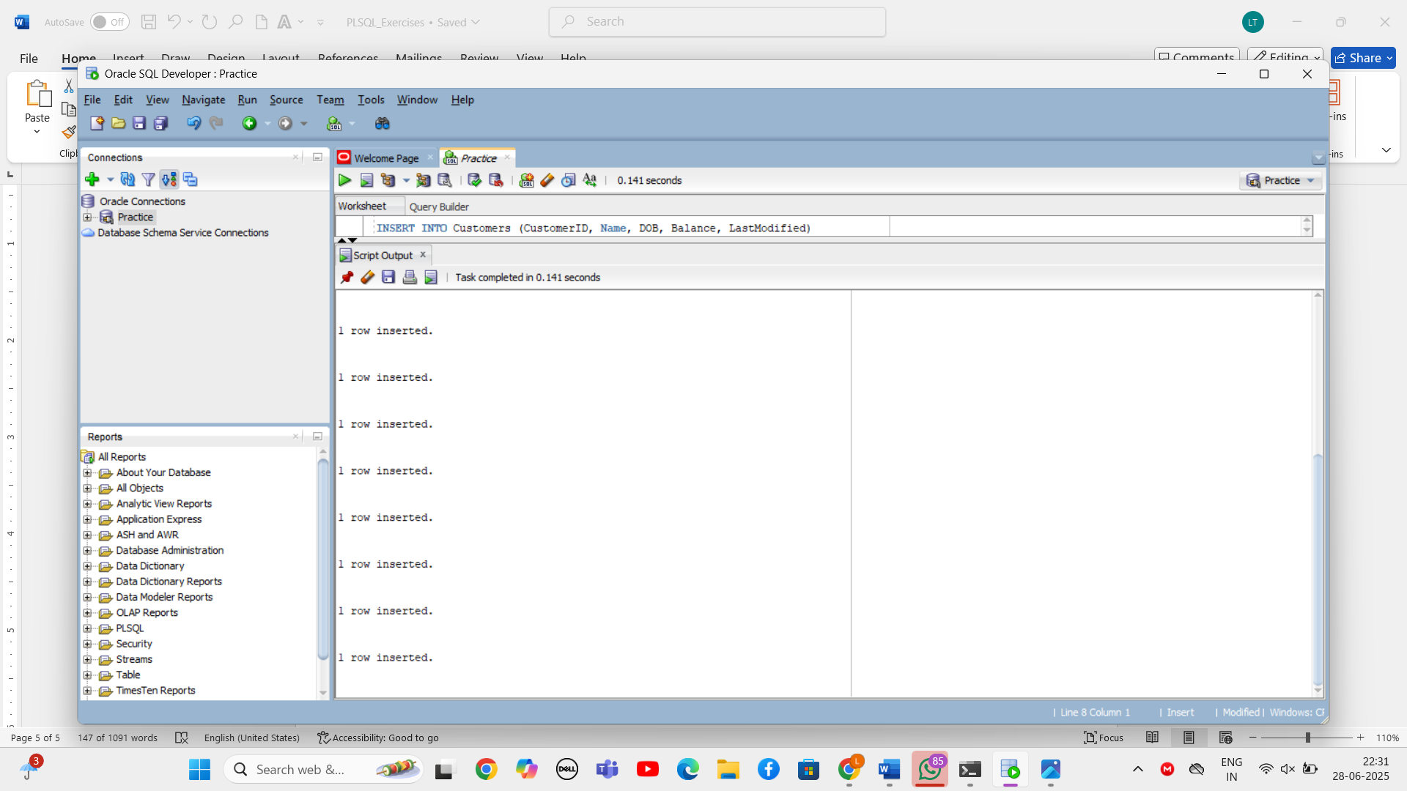

**Exercise 1: Control Structures**

**Scenario 1: The bank wants to apply a discount to loan interest rates for customers above 60 years old.**

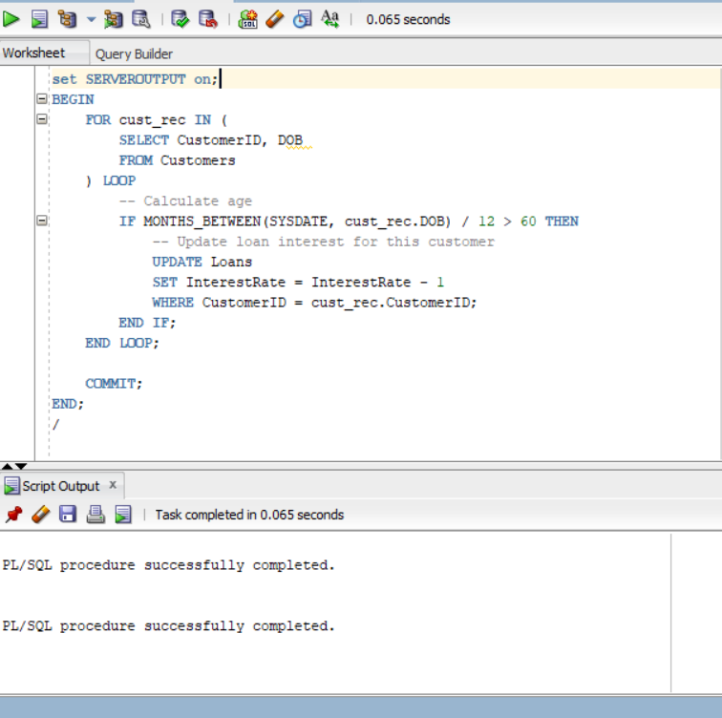**Solution:**

**Scenario 2: A customer can be promoted to VIP status based on their balance.**

**Solution:**

1. ALTER TABLE Customers ADD IsVIP VARCHAR2(5);
2. BEGIN

FOR cust IN (

SELECT CustomerID, Balance FROM Customers

) LOOP

IF cust.Balance > 10000 THEN

UPDATE Customers

SET IsVIP = 'TRUE'

WHERE CustomerID = cust.CustomerID;

ELSE

UPDATE Customers

SET IsVIP = 'FALSE'

WHERE CustomerID = cust.CustomerID;

END IF;

END LOOP;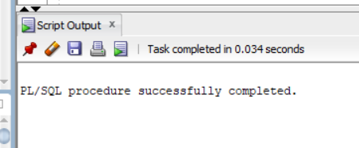

COMMIT;

END;

**Scenario 3: The bank wants to send reminders to customers whose loans are due within the next 30 days.**

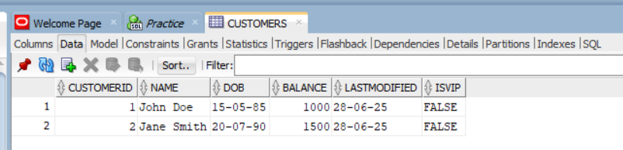**Solution:**

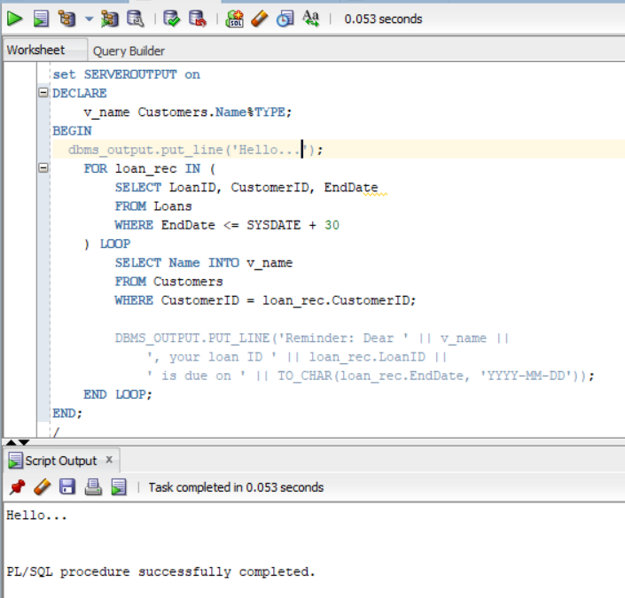

**Exercise 3: Stored Procedures**

**Scenario 1: The bank needs to process monthly interest for all savings accounts.**

**Solution:**

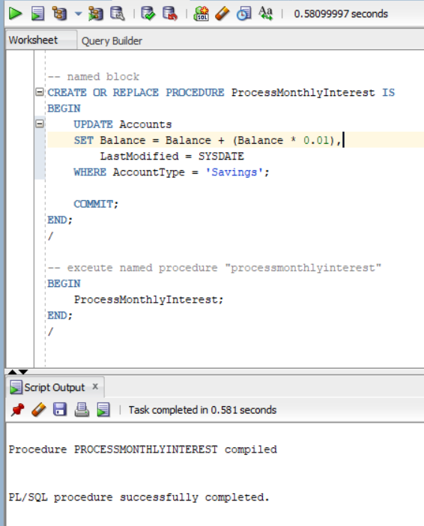

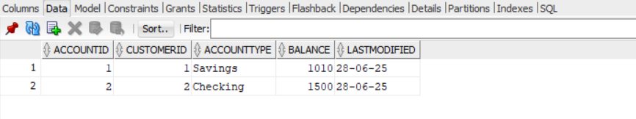

**Scenario 2: The bank wants to implement a bonus scheme for employees based on their performance.**

**Solution:**

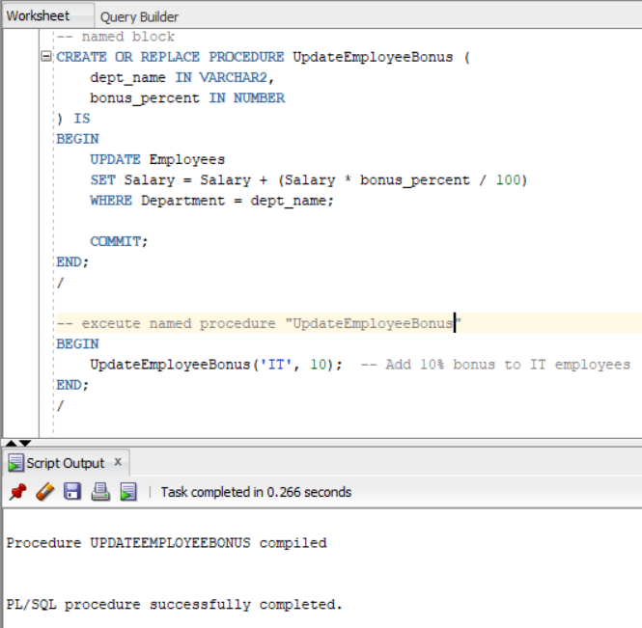

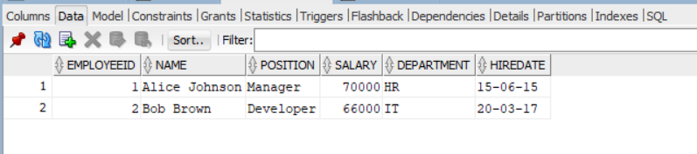

**Scenario 3: Customers should be able to transfer funds between their accounts.**

**Solution:**

**-- named block**

CREATE OR REPLACE PROCEDURE TransferFunds (

from_account IN NUMBER,

to_account IN NUMBER,

amount IN NUMBER

) IS

source_balance NUMBER;

BEGIN

-- Get source account balance

SELECT Balance INTO source_balance

FROM Accounts

WHERE AccountID = from_account;

-- Check if sufficient balance

IF source_balance >= amount THEN

-- Deduct from source

UPDATE Accounts

SET Balance = Balance - amount,

LastModified = SYSDATE

WHERE AccountID = from_account;

-- Add to target

UPDATE Accounts

SET Balance = Balance + amount,

LastModified = SYSDATE

WHERE AccountID = to_account;

COMMIT;

ELSE

RAISE_APPLICATION_ERROR(-20001, 'Insufficient balance in source account.');

END IF;

END;

/

